# Code Smells

## Comments

### Illustrating code snippet

### 

### Class location

/ganttproject/src/main/java/net/sourceforge/ganttproject/AbstractChartImplementation.java

### Explanation

The class is missing any form of comments describing the functionality of its methods, making it harder to understand.

### Refactoring proposal

Add descriptive enough comments to make it easier to read the code.

## Large class

### Illustrating code snippet

### 

### Class location

/ganttproject/src/main/java/net/sourceforge/ganttproject/calendar/CalendarEditorPanel.java

### Explanation

This class is too large, indicating it has too many responsibilities and less organization.

### Refactoring proposal

Creating more specific classes that take care of smaller sets of actions the original class was responsible for.

## Shotgun Surgery

### Illustrating code snippet

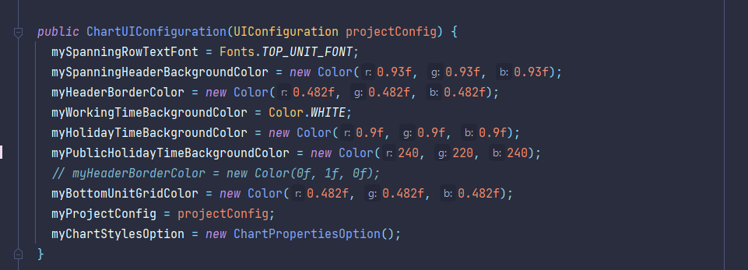

### Class location

/ganttproject/src/main/java/net/sourceforge/ganttproject/chart/ChartUIConfiguration.java

### Explanation

Changing colors in any part of the code may be harder than intended given that there is no general definition for such.

### Refactoring proposal

Create constants responsible for holding each color used throughout the code.